PURBANCHAL UNIVERSITY
ACME ENGINEERING COLLEGE
DEPARTMENT OF ARCHITECTURE
SITAPAILA, KATHMANDU

DESIGN STUDIO VI
A REPORT ON ESORT DESIGN
SUBMITTED BY:
Wiplove Amir Shek Pakhrin
078/B-ARCH-05
SUBMITTED TO:
Ar. MUKUNDA SHYAM RANJIT
Ar. SAMITA SHRESTHA
Ar. SUSAN VAIDYA

Acknowledgement

We extend our deepest gratitude to all those who have contributed to the successful design and planning of this resort.
First and foremost, we thank our project supervisor, Ar. Samita Shrestha and Ar. Mukunda Shyam Ranjit, for their invaluable guidance, insightful feedback, and unwavering support throughout the development of this project.
We would also like to express our appreciation to the faculty and Department of Architecture for providing us with the necessary resources and facilities to carry out this project.
A special thanks to our peers and classmates for their continuous encouragement, constructive criticism, and collaborative spirit, which greatly enhanced the quality of our work.

Contents
Acknowledgement 2
1. INTRODUCTION 4
2. CLASSIFICATION OF RESORTS 4
2.1. Hill resorts: 4
2.2. Beach resorts: 4
2.3. Island Resort: 4
2.4. Lake Resort: 5
2.5. Pet-friendly Resort: 5
2.6. Golf Resort: 5
2.7. Spa Resort: 5
3. TYPES OF RESORTS 6
4. FUNCTION OF RESORT 6
5. FACILITIES AT A RESORT 7
6. REQUIREMENTS OF RESORTS: 7
7. Area of analysis 8
7.1. Market Analysis 8
7.2. Location Analysis 8
7.3. Resort Facilities and Amenities 9
7.4. Financial Analysis 9
7.5. Customer Experience and Satisfaction 9
7.6. Sustainability and Environmental Impact 9
7.7. Marketing and Sales Strategies 10
7.8. Risk Analysis 10
8. Case study 10
8.1. Tigerland Chitwan 11
9. Concept 13
9.1. Concept sheet: 13
9.2. Zoning: 13
9.3. Design elements: 14
10. Conclusion 16

INTRODUCTION
This report outlines the conceptualization, design, and planning of a unique resort inspired by the natural phenomenon of a whirlpool. The design aims to combine aesthetic appeal with functional spaces that foster community and recreation. The resort's layout, architecture, and amenities have been thoughtfully planned to provide an unforgettable experience for guests.

CLASSIFICATION OF RESORTS
Resorts may be classified into 4 categories Depending on Location:

Hill resorts:
These generally spring up in areas abounding natural beauty in form of hills, mountains, streams, rivers, lakes another point of beauty so top and all this area must boost a good climate throughout the season.

Beach resorts:
These generally spring up at points of exceptional beauty having clear water and long stretches of good beaches.

Island Resort:
These resorts are situated on an island. The amenities offered by the resort usually include fishing, snorkeling, and swimming, sun bathing, boating, kayaking, and parasailing, together with other kinds of water sports.

Lake Resort:
Such resorts are primarily located directly on or in close proximity to lake. Lake resorts are popular among the travelers for adventures like swimming, boating, fishing, or water skiing.

Pet-friendly Resort:
Such resorts allow the entry of pets such as dogs and cats in the rooms. Some pet-friendly resorts might put restrictions on the size of the pet.

Golf Resort:
These resorts specifically cater to the sport of Golf, and take in one or more golf course and or clubhouse. Golf resorts typically offers Golf packages to visitors that consist of cart fees, range balls, luxury accommodations and meals. Accommodation in such resorts is available in form of hotel like rooms or personal spacious villas.

Spa Resort:
It is a short-range lodging facility with the main idea of providing spa services to extend healthy habits of visitors. Traditionally, such spas were located near natural hot springs or sources of mineral waters. Typically, a week stay is an all-inclusive program that includes spa services, healthy cuisine, wellness education and physical fitness activities.

TYPES OF RESORTS
- Mountain / Hill resort
- Beach resort.
- Tropical resort
- Luxury resort
- Island resort
- Lake resort
- Golf resort
- Spa resort
- Pet-friendly resort
- Theme park resort.

FUNCTION OF RESORT
- Accommodation
- Fooding
- Relaxation
- Gaming
- Meeting
- Marriage
- Club
- Boating
- Party
- Seminar
- Dancing

FACILITIES AT A RESORT
- Conference
- Banquet halls
- TV lounge
- Recreation etc…

REQUIREMENTS OF RESORTS:
- Entrance
- Reception
- Lobby
- Bedroom with comfortable bath
- Gym
- Sports
- Swimming pool (indoor/outdoor)
- Landscape
- Seminar hall
- Amphitheatre
- Garden
- Club
- Library
- Kids play arena boating
- Kitchen
- Dining
- Pathways
- Bar
- Saloon
- Meeting room
- Marriage hall
- Staff room
- Manager room
- Store room
- Spa facilities
- Restaurant
- Rooms of different categories

Area of analysis

Market Analysis
- Target Audience: Primarily families, couples, and business travelers from urban areas, aged 25-50.
- Market Trends: Increased demand for eco-friendly and wellness-focused resorts.
- Competitive Landscape: Nearby resorts offering similar amenities, differentiated by unique experiences and loyalty programs.

Location Analysis
- Geographic Location: Situated on a picturesque beachfront, offering scenic views.
- Accessibility: Accessible via a 30-minute drive from the nearest airport and close to major highways.
- Local Attractions: Proximity to popular tourist spots like national parks, heritage sites, and adventure sports.

Resort Facilities and Amenities
- Accommodation: Variety of room types including suites and villas, maintaining an average occupancy rate of 80%.
- Dining: Multiple restaurants offering diverse cuisines, from local to international dishes.
- Recreational Facilities: Includes a spa, multiple swimming pools, a fitness center, and sports courts.
- Event Facilities: Conference halls, wedding venues, and outdoor event spaces with full catering services.

Financial Analysis
- Revenue Streams: Room rentals, dining, spa services, event hosting, and recreational activities.
- Cost Structure: Major costs include staff salaries, utilities, and maintenance.
- Profitability: Maintains a healthy profit margin with consistent growth in revenue year over year.

Customer Experience and Satisfaction
- Guest Reviews and Feedback: Generally positive reviews on platforms like TripAdvisor and Google, with an average rating of 4.5 stars.
- Service Quality: High standards of customer service with trained staff.
- Loyalty Programs: Offerings include membership discounts, exclusive deals, and rewards for repeat guests.

Sustainability and Environmental Impact
- Eco-Friendly Practices: Solar energy usage, water conservation initiatives, and recycling programs.
- Community Involvement: Partnerships with local businesses and community events, promoting cultural tourism.

Marketing and Sales Strategies
- Marketing Channels: Strong online presence with active social media campaigns and collaborations with travel influencers.
- Promotional Activities: Seasonal discounts, holiday packages, and special offers for extended stays.
- Sales Performance: Steady increase in booking rates and customer acquisition through targeted marketing.

Risk Analysis
- Operational Risks: Challenges with staff turnover and maintaining service quality.
- Market Risks: Economic fluctuations affecting travel and tourism, particularly during off-peak seasons.
- Environmental Risks: Vulnerability to natural disasters like hurricanes and rising sea levels due to climate change.

Case study

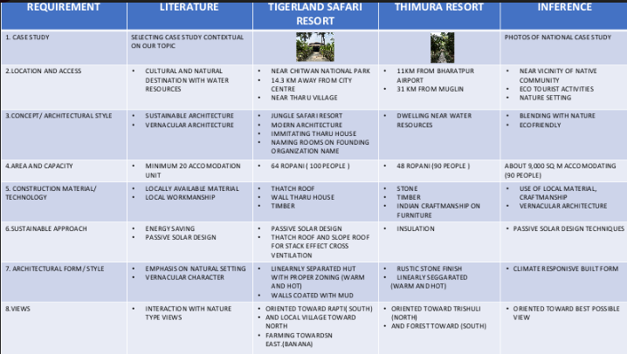

Tigerland Chitwan

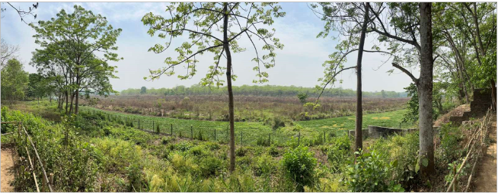
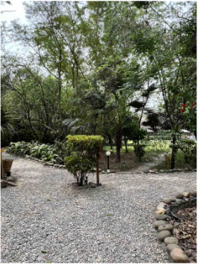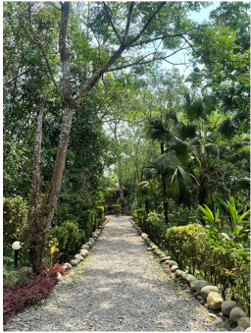
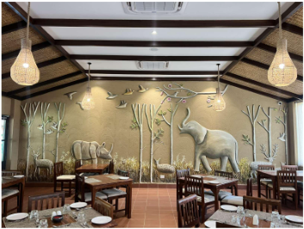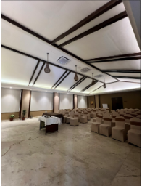

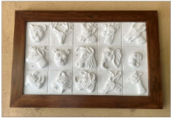
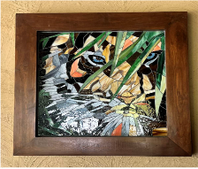

Concept

Concept sheet:
The design is inspired by the natural beauty and dynamic movement of rivers and whirlpools, symbolizing both the power and tranquility of water. Arranged in a spiral or circular pattern, it mimics the swirling motion of a whirlpool, drawing guests toward the central areas.

Zoning:
The resort's zoning strategy is designed to optimize functionality, accessibility, and guest experience. The first level includes key communal areas such as the restaurant and reception, while the accommodation areas are zoned downward to provide privacy and a serene environment for guests.

Design elements:
Incorporating vernacular architectural elements such as stone, thatch roofs, and wood creates a harmonious and sustainable design that respects local traditions and materials. This approach not only enhances the aesthetic appeal of the resort but also promotes environmental sustainability by utilizing locally sourced, eco-friendly materials.

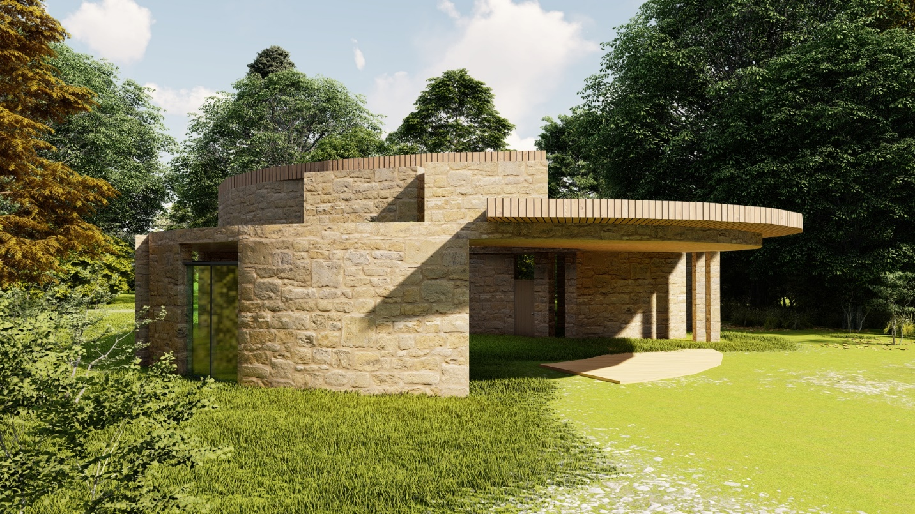
Figure A Resort1

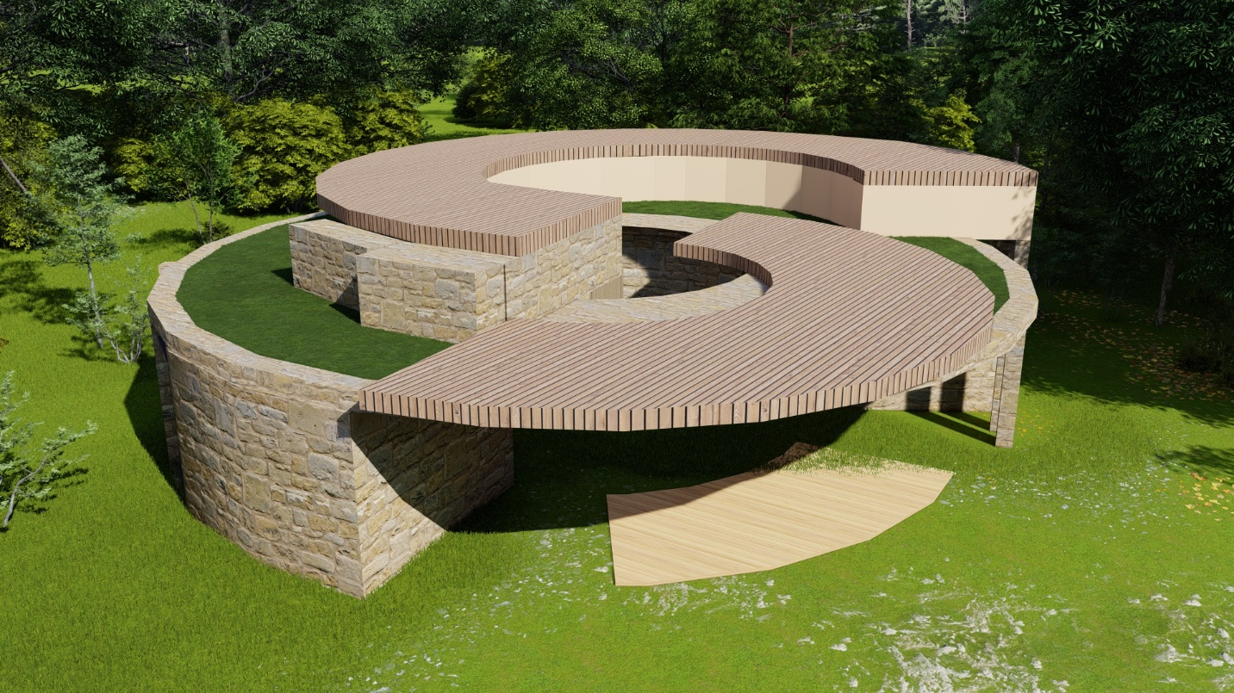
Figure B Resort2

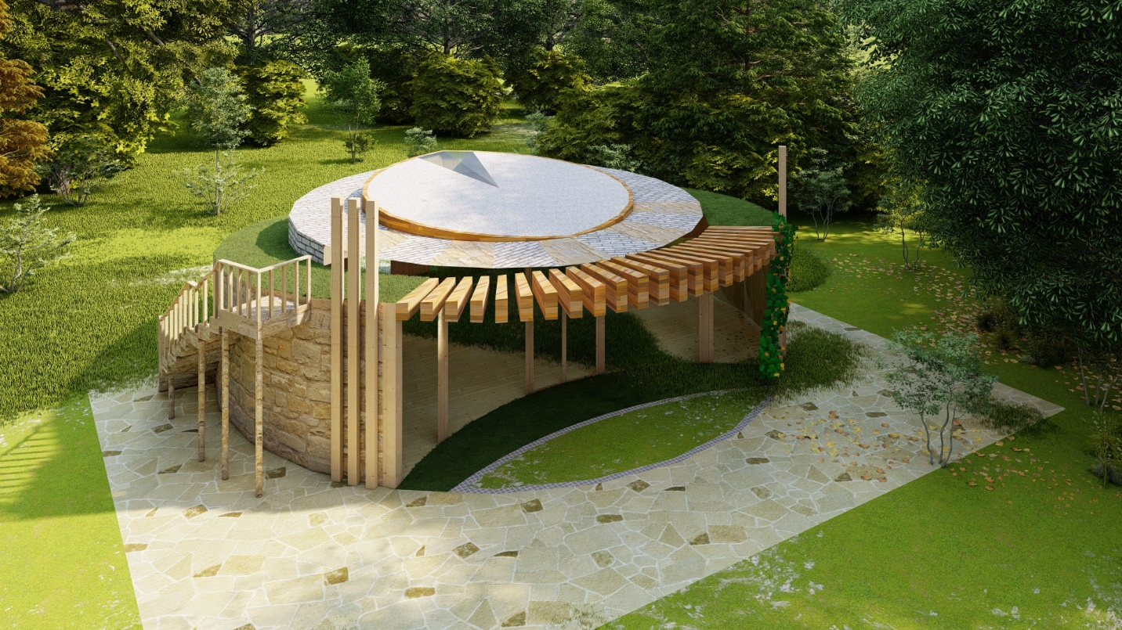
Figure C Resort3

Conclusion
The resort’s design and zoning strategy are thoughtfully crafted to enhance both functionality and guest experience while maintaining a deep respect for local traditions. By integrating vernacular architectural elements like stone, thatch roofs, and wood, the resort achieves a harmonious and sustainable aesthetic. The strategic zoning, with communal areas on the first level and private accommodation zoned downward, ensures accessibility and privacy. This approach not only creates a visually appealing environment but also fosters a serene and immersive experience for all guests, emphasizing sustainability and cultural appreciation.

